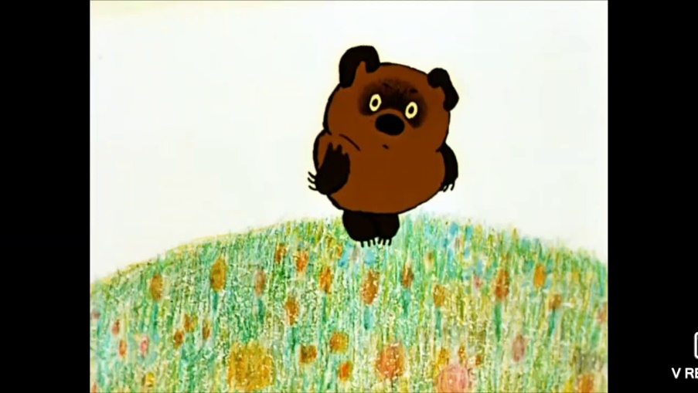

Figure 1russian Vinny the poo

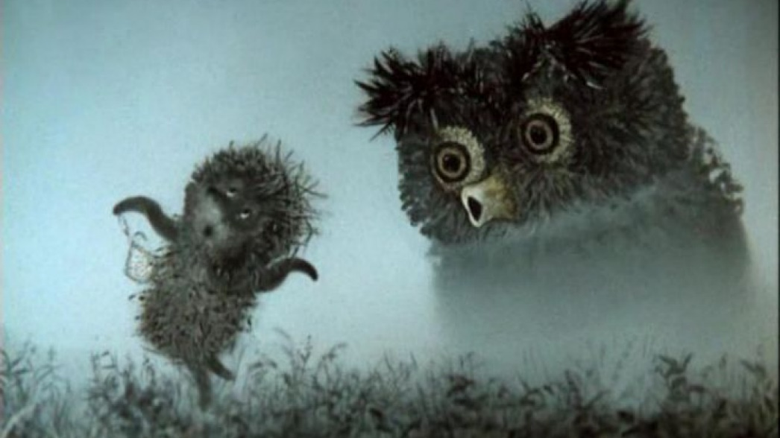

Figure 2 Russian Cartoon "The hedgehog"

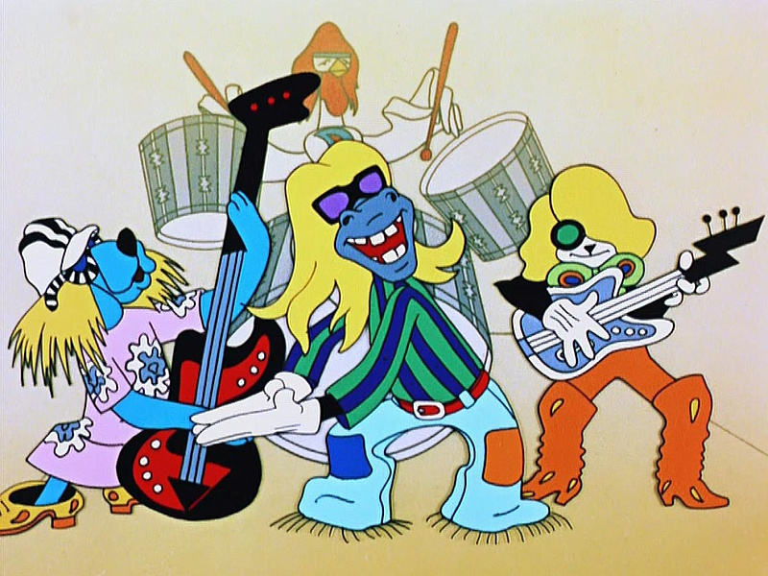

Figure 3 Russian Cartoon "Бременскике музыканты"

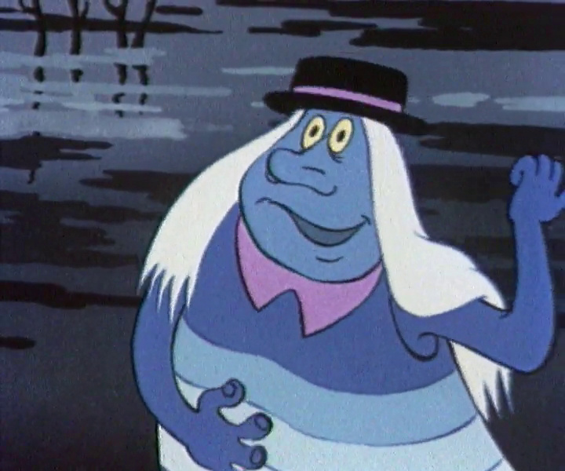

Figure 4 Russian cortoon "Flying ship" Vodyanoi

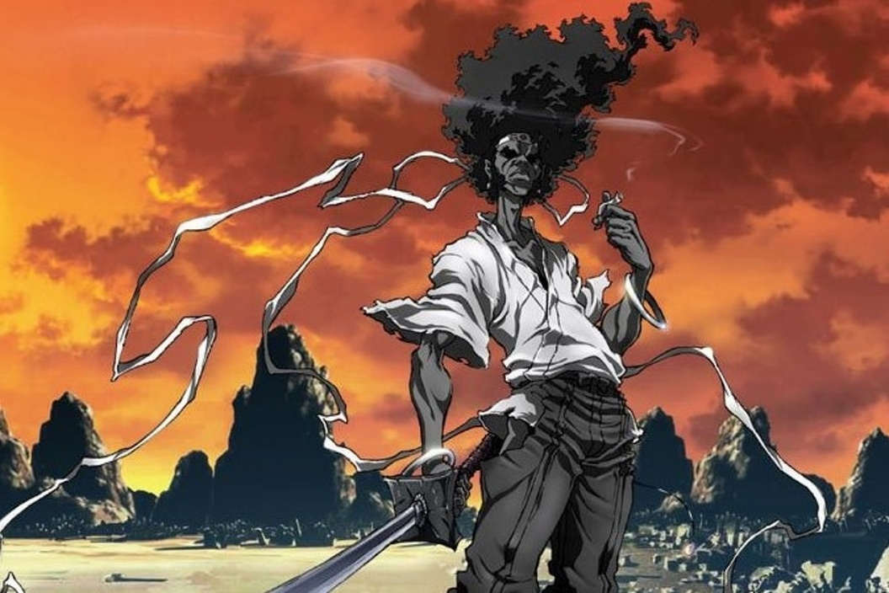

Figure Afro Samurai

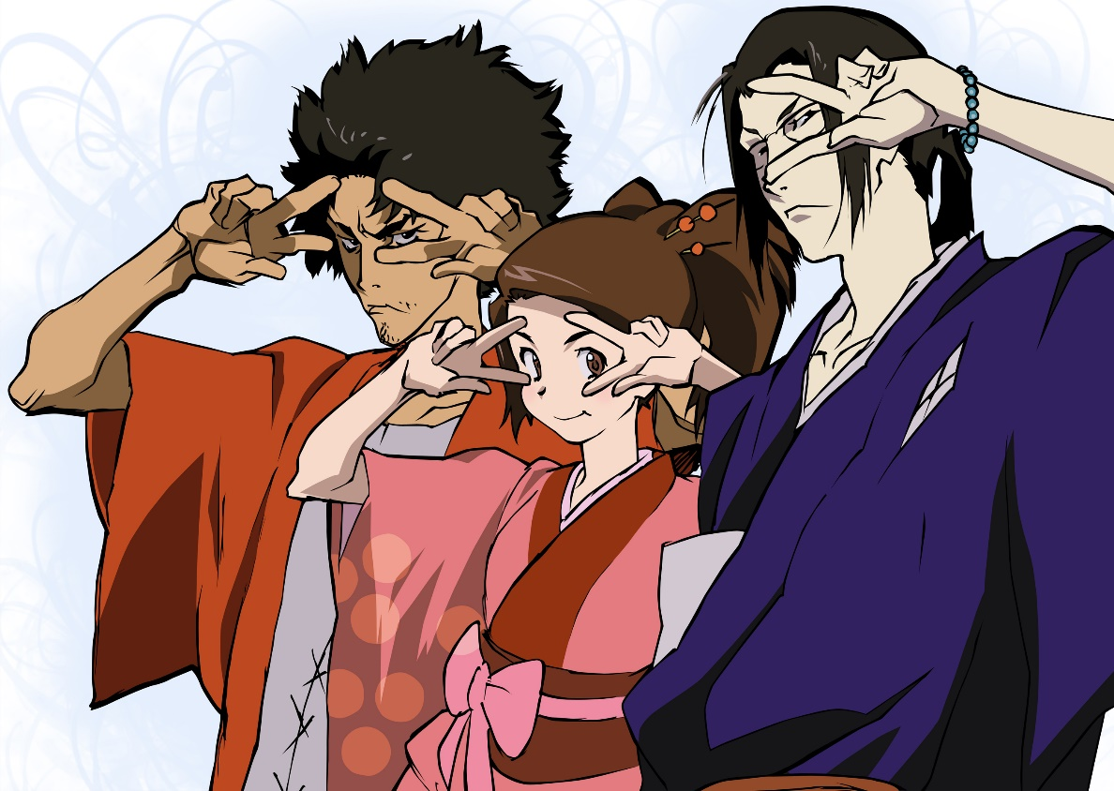

Figure Samurai Champloo

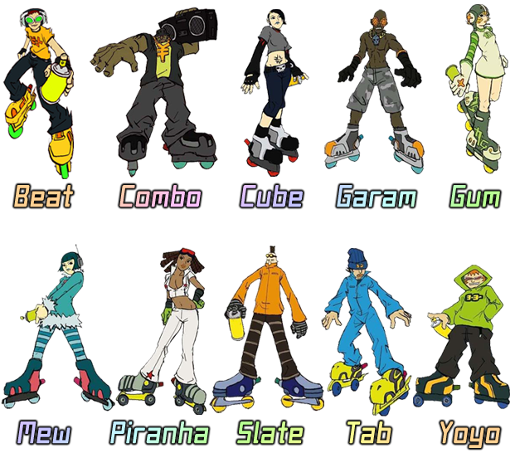

Figure 7 Jet Set Radio characters

Figure 8 Glukoza russian cartoon singer



Figure Sponge BOB

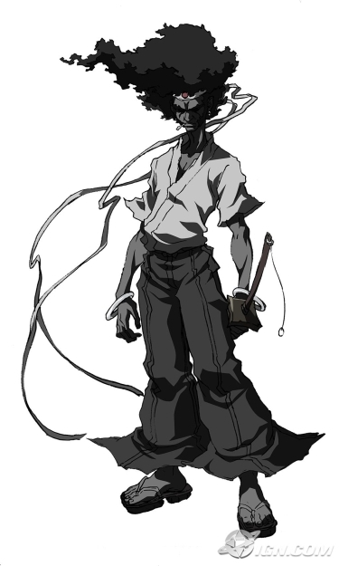

Describing this character.   
He has a long body with a triangular head and a very manly muscular figure. Which can tell us about his physical strength and his attitude. He is a protagonist and an aggressive fighter/samurai.

My character

Name: Davenchik Glebon

Gender: male

Age: around 36

Ethnicity/Species: half frog/reptile/human

Family: his friends like Dolbanaya Mary, Sirnik, Sernik, Sarnyak and Aunt Makwede

Cultural background: Russian housekeeper

Intelligence: smart, good at communication

Occupation: a friend/housekeeper

Religion/philosophy: Buddhist, spiritual

Sexual orientation: pansexual

Goals, Ambitions, Dreams: to fly on an air balloon and eat chicken legs with grapes

Secrets: secretly knows the key to peace and love in the world, but it too dangerous to tell anyone, could semi predict the future

Fears/Phobias: is kind of scared of Dolbanaya Mary because she is a bit crazy and Aunt Makwede because he wants her to really like him so is scared of doing anything to tip her over.